**Dragon Food GINA Instructions**

1. 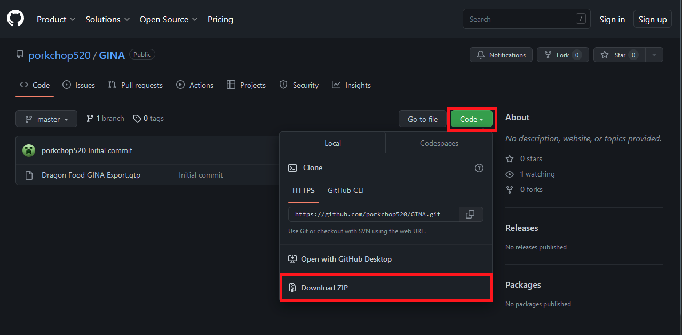Download the latest pack of GINA triggers by visiting <https://github.com/porkchop520/GINA> and clicking the green ‘Code’ button then ‘Download ZIP’.
2. 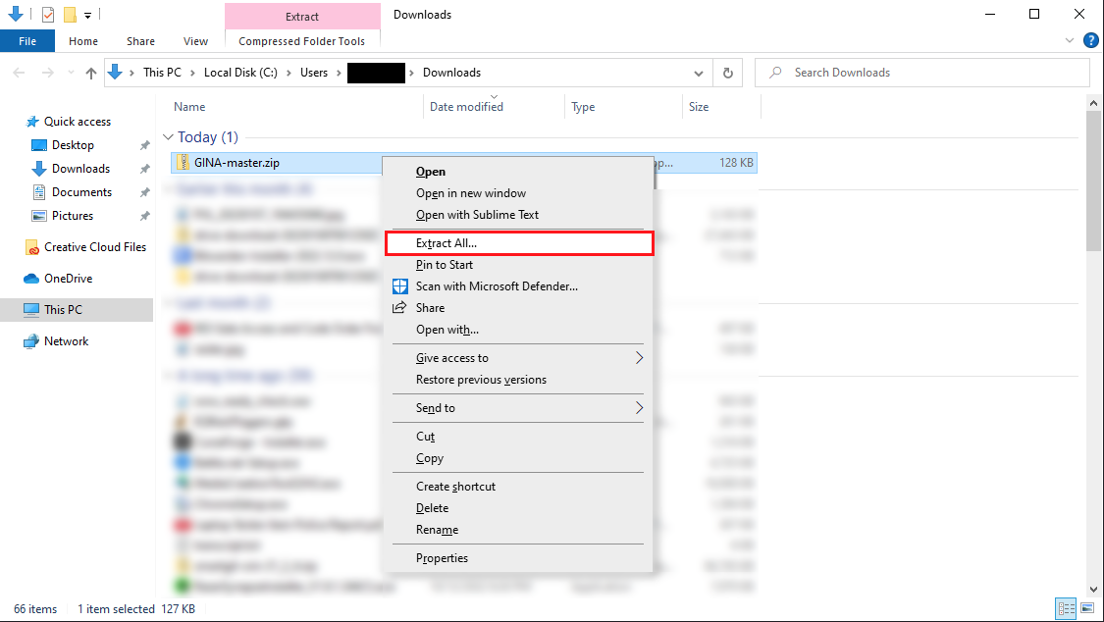Locate your downloaded file and unzip the file(s) by right clicking on the file and clicking ‘Extract All…’. Click the ‘Extract’ button on the next window that pops up.
3. 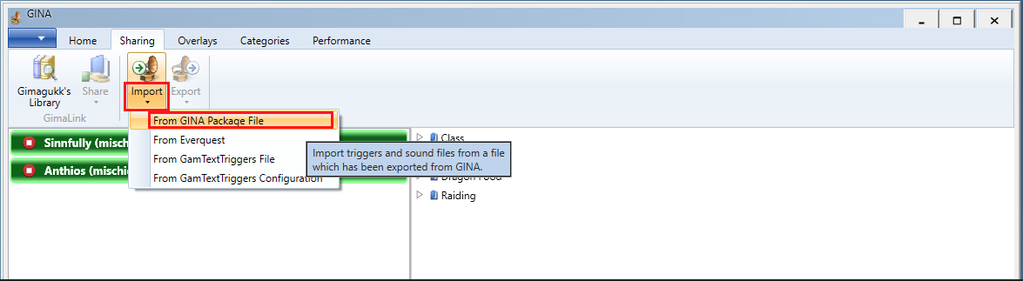Once downloaded, open GINA, click the ‘Sharing’ tab at the top, then click the ‘Import’ button and select ‘From GINA Package File’.
4. 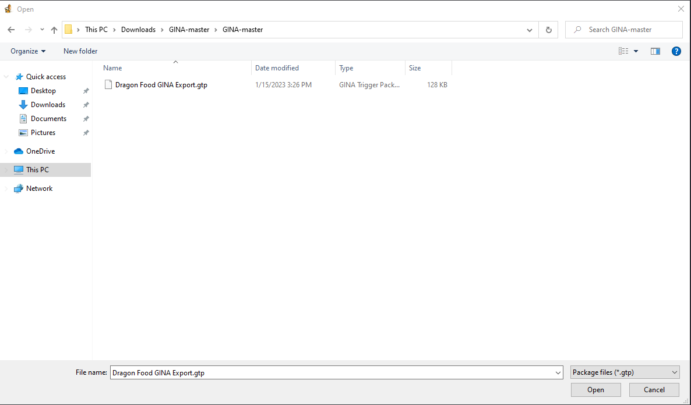Browse to your downloaded file location and locate the file ‘Dragon Food GINA Export.gtp’. Click the ‘Dragon Food GINA Export.gtp’ file and click ‘Open’
5. From here you have one of two options: Allow GINA to automatically merge the package for you, or manually merge the triggers yourself.
   1. 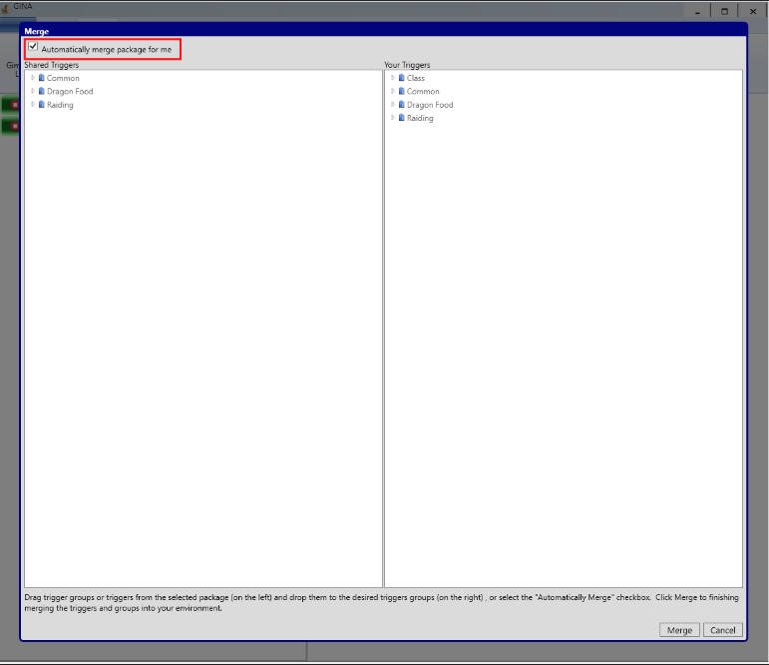Allow GINA to automatically merge the package  
      On the next page, ensure the ‘Automatically merge package for me’ checkbox is **checked** and hit the ‘Merge’ button at the bottom. Then you’re done!
   2. 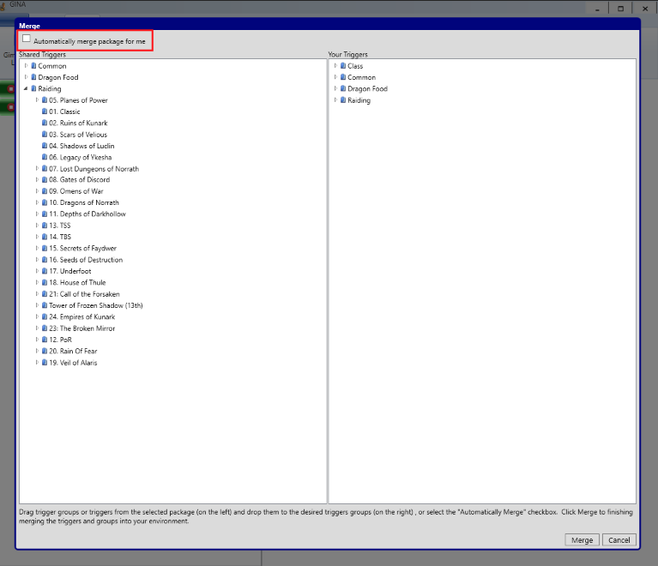Manually merge the triggers yourself  
      On the next page, ensure the ‘Automatically merge package for me’ checkbox is **unchecked.** Once this is done the window under ‘Shared Triggers’ will become useable and you can drag each trigger and/or folder over yourself.  
        
      Once you’re done moving over the triggers that you like by dragging from the left pane to the right pane, click the ‘Merge’ button at the bottom and you’re done!